Taint and POD migration to others Nodes

Step 1 : List the nodes

kubectl get nodes

Step 2 : delete all deployments

kubectl delete deploy --all

Step 3 : create deployment1

vim deployment1.yaml

apiVersion: apps/v1

kind: Deployment

metadata:

name: ajay1

spec:

replicas: 3

selector:

matchLabels:

app: ajay

template:

metadata:

labels:

app: ajay

spec:

containers:

- name: ajay

image: nginx

ports:

- containerPort: 80

kubectl create -f deployment1.yaml

Step 4 : List the PODS for deployment1 - you will notice PODS are on different nodes

kubectl get pods -o wide



Step 5: Taint worker2 node in your node list

kubectl taint node s14worker2.cloudenabled.net key=value:NoSchedule

Step 6: Describe worker2 to check the implications.

kubectl describe node s14worker2.cloudenabled.net

Step 7 : create deployment2

vim deployment2.yaml

apiVersion: apps/v1

kind: Deployment

metadata:

name: ajay2

spec:

replicas: 3

selector:

matchLabels:

app: ajay

template:

metadata:

labels:

app: ajay

spec:

containers:

- name: ajay

image: nginx

ports:

- containerPort: 80

kubectl create -f deployment2.yaml

Step 8: Check no pod scheduled on the node which is tainted

kubectl get pods -o wide

Step 9: Evacuate /recreate PODS running on worker2 to any other available worker node

kubectl taint node s14worker2.cloudenabled.net key=value:NoExecute

taint other node with the value as NoExecute you should notice the node which is tainted with NoExecute does not have pods running now they are migrated to other nodes.

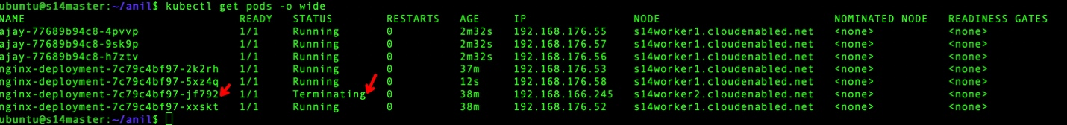

You can notice all PODS from worker2 will be now deployed on worker1



Step 10 : To untaint and aloww deployment to worker node

kubectl taint node s14worker2.cloudenabled.net key=value:NoExecute-

kubectl taint node s14worker2.cloudenabled.net key=value:NoSchedule-